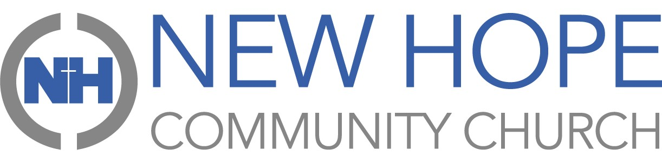
PRAYER CALENDAR Dec2025
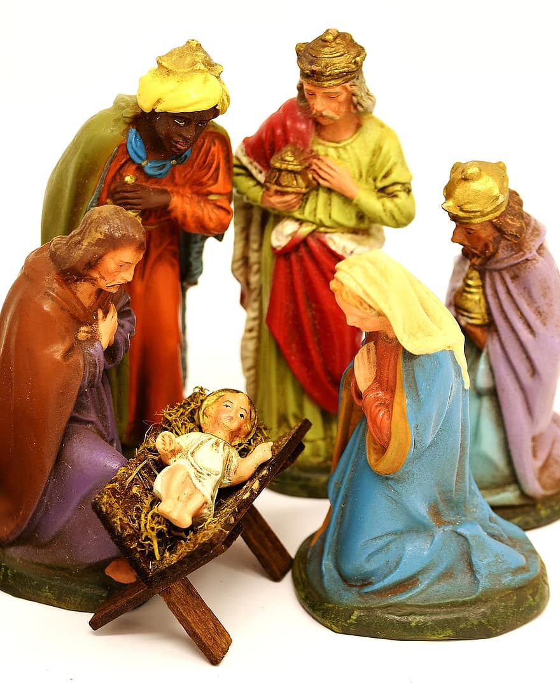
Sun | mon | tue | wed | thu | fri | sat
 | 01 | 02 | 3 | 4 | 5 | 6
 | Leadership/Staff Team at New Hope | Jason Zizzo (health); Gary Michel (health) | The Lost & Unredeemed | Michael Todd (health) | College Students (final exams) | Sunday Morning Ministries
7 | 8 | 9 | 10 | 11 | 12 | 13
Hope Kids/Fusion | Rick Hewitt (health) | Women of Hope | New Hope’s congregation and volunteers | Hope Central and families in need | Studio Bee (Missions) | Sunday Morning Ministries
14 | 15 | 16 | 17 | 18 | 19 | 20
Hope Kids/Fusion; Pastor Andy & family | High School Students (final exams) | Student Christian Fellowship (Missions) | Stuart’s Small Group | Business Team | Fusion Lock-in | Sunday Morning Ministries
21 | 22 | 23 | 24 | 25 | 26 | 27
Hope Kids/Fusion; Transcendent Healthcare North | Elder Team | Wisdom & Grace (Missions in Guatemala) | Family Relationships | The birth of Jesus Christ Our Savior | Transcendent Healthcare North (Missions) | Sunday Morning Ministries
28 | 29 | 30 | 31
Hope Kids/Fusion | Binding Thread (Missions) | Praises for our many blessings during 2025; Butch Harper (health) | God’s continued faithfulness for New Hope in 2026
Advent – a time when Christians prepare with anticipation for the coming of the Messiah. Advent is also a time for worshipful reflection and prayer as we prepare our souls for the Return of Christ.

